Desktop

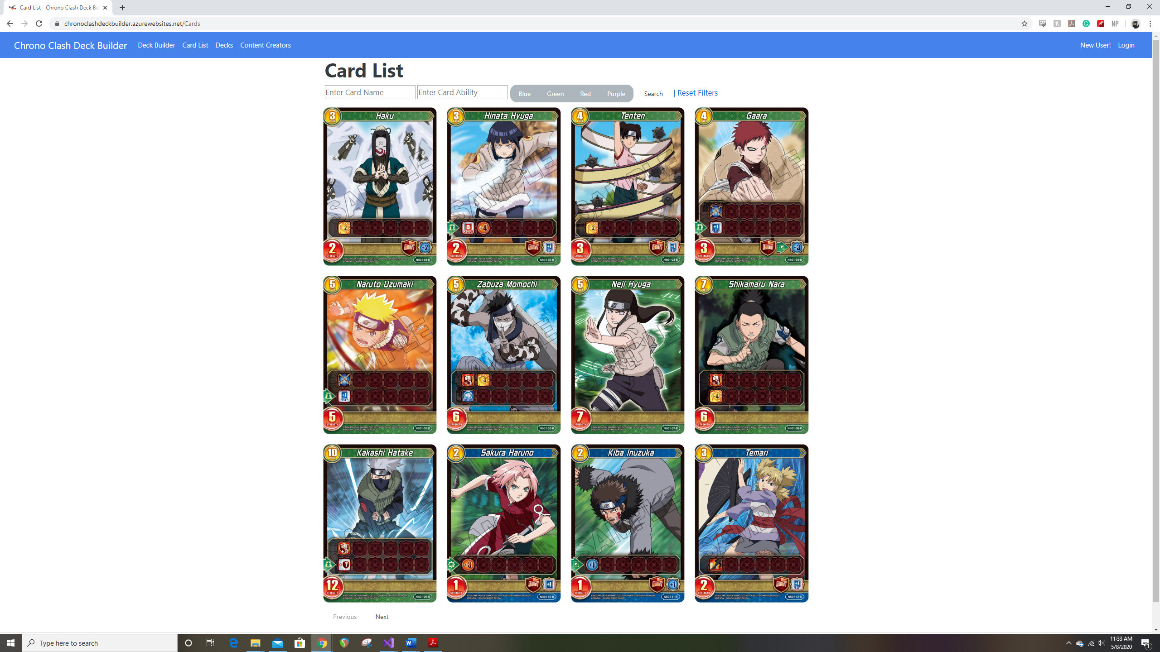

Mobile

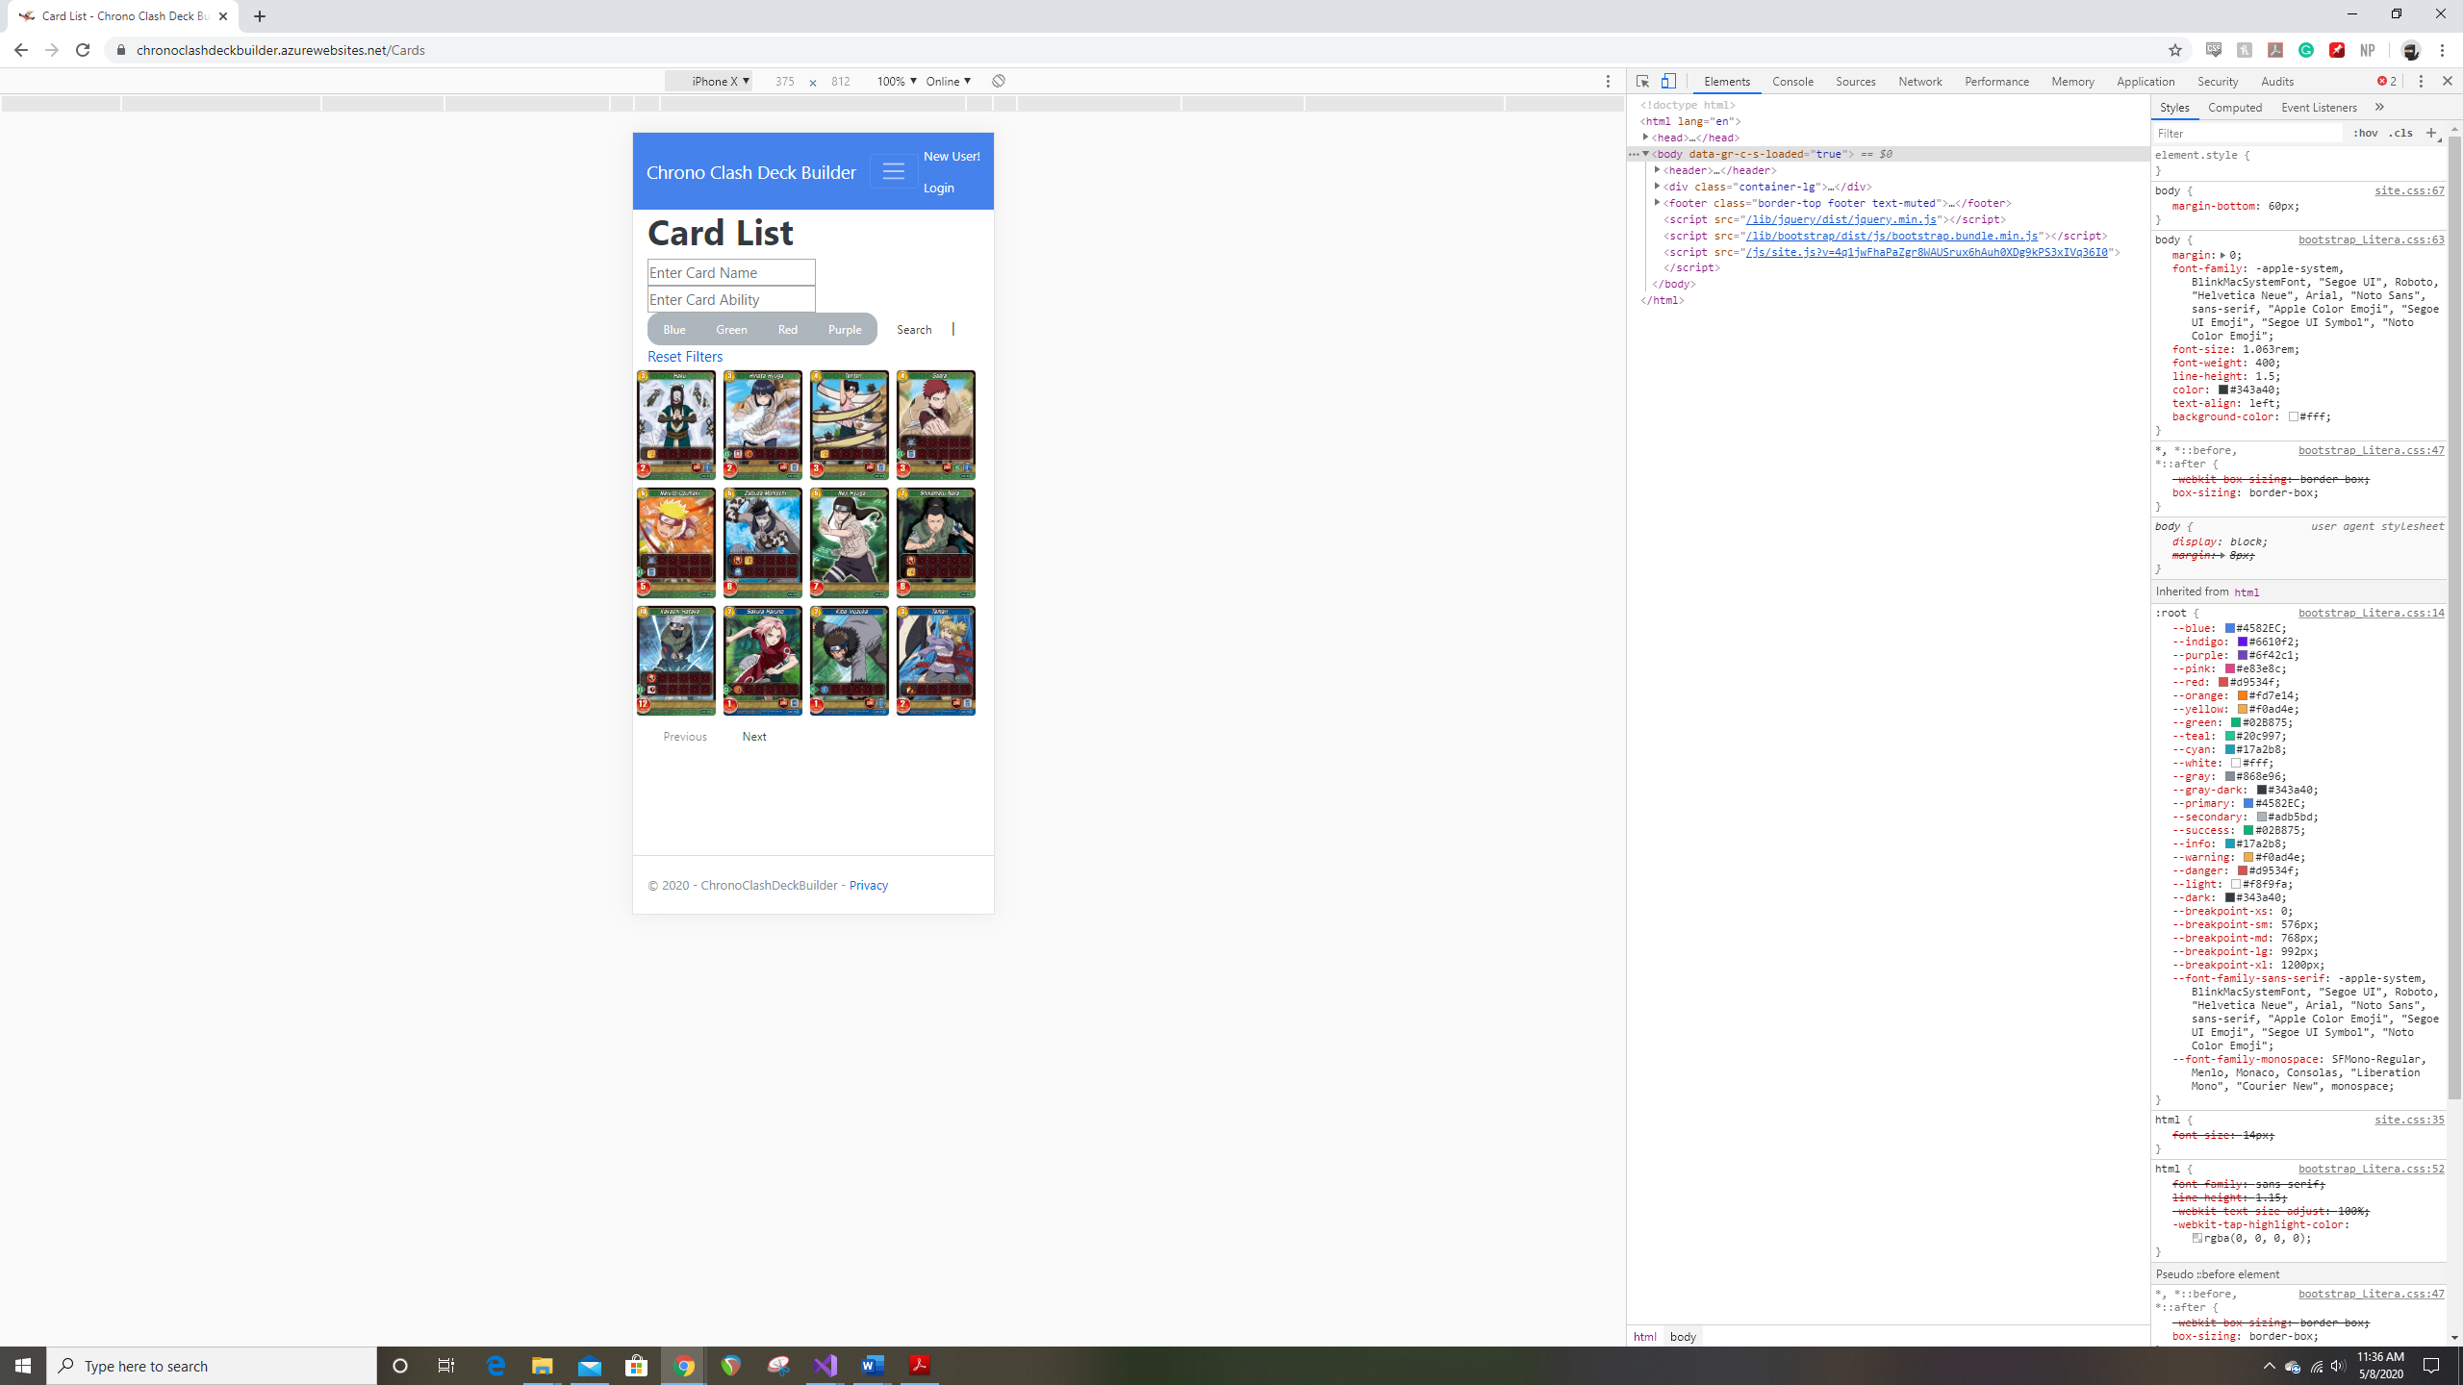

Mobile Horizontal

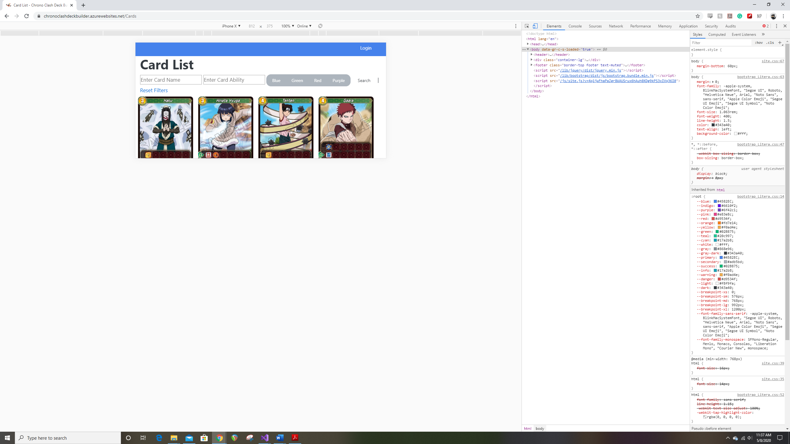

Sprint 3 – I’ve successfully added a session variable to store the list of cards selected on the deck builder page, which were my only tasks for the week, as they were giving me difficulties the past several weeks.

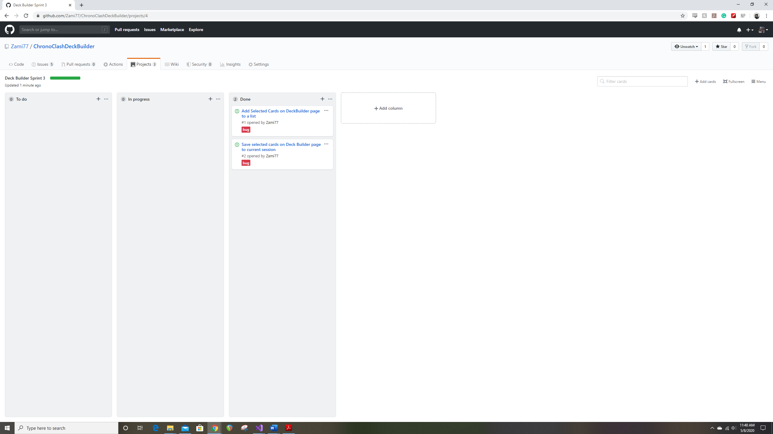s